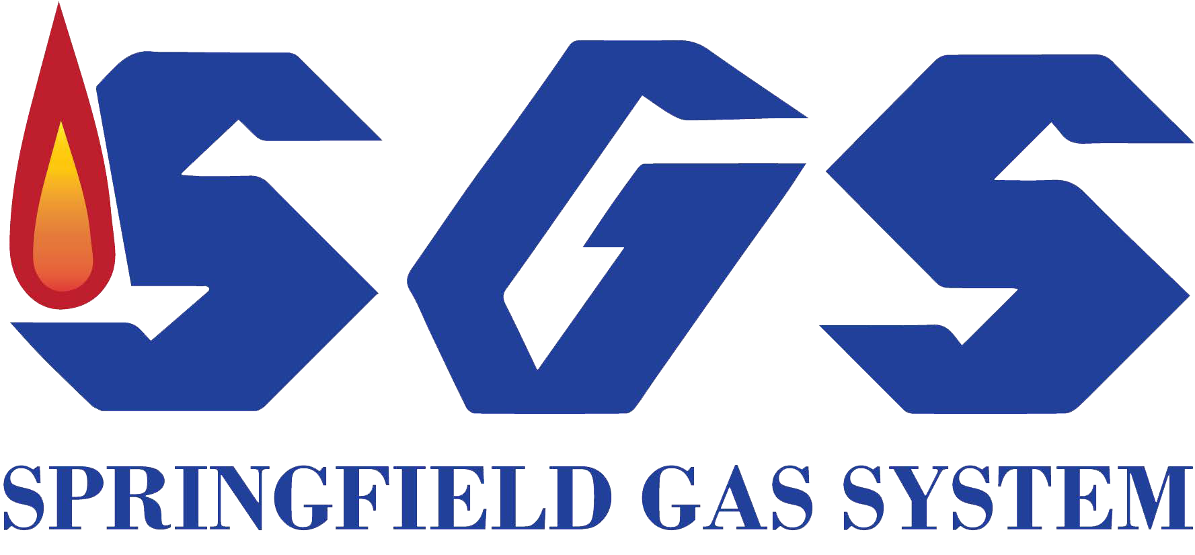
SPRINGFIELD GAS SYSTEM SURVEY QUESTIONS FOR EMERGENCY RESPONDERS

NAME ADDRESS PHONE OCCUPATION
Springfield Gas System believes it is important to get feedback from people such as you about pipeline safety. We would like to ask you a few questions and would greatly appreciate your candid answers. The information on your particular response will be kept confidential.

- Do you have natural gas pipelines running through your community?

- Do you know the name of your local natural gas company?
2a. If yes, who?

- Have you heard or seen a message regarding natural gas safety in the last 12 months? 3a. If yes, about how many?

- Before today, about when was your last contact with someone from the natural gas industry related to pipeline safety? (If known, fill in approximate date or number of weeks, months, or years ago.)

- Do you have the number to call in the natural gas company if there is an incident or you need more information?

- Do you know who regulates the natural gas company in this State? (If no, they should be informed about it.)

- Do you know what precautions an excavator should take prior to digging, to avoid accidentally hitting a natural gas pipeline?
7a. If yes, what are they?
- Are you familiar with the one-call line?

- How would you rate the adequacy of information you have about natural gas safety (e.g., how to recognize a leak, what to do when there is a leak, what first responders should do, etc.)?
About right? Too much? Not enough?

- Does your community have an emergency response plan to deal with a natural gas leak (regardless of whether intentional or accidental)?

- Are you aware of any pipeline leaks that occurred in your community in the last 2 years? ________
11a. If yes, how many?
11b. What were they?

- Have any of your local citizens or businesses expressed concern in the last 12 months about any issue regarding natural gas safety? (Y/N)
12a. If yes, what was it?

- Overall, do you feel the natural gas industry has an adequate public safety awareness program?

Definitely yes Probably not
Pretty much so Not sure Don’t know
Definitely not

- Do you know how to contact the local natural gas company if there is an incident, or if you need more information?

- Have you seen, heard, or received any information regarding natural gas safety in any media in the last year?
15a. If yes, do you recall what?

- Have you or anyone else in your department to your knowledge met with any representatives of the natural gas company to discuss pipeline safety within the last 12 months, prior to today?

16a. If yes, when?
16b. With whom?

- Do you have a response plan or SOPs for responding to a natural gas incident, such as a leak?

- Have you done any practical training to deal with a leak?

- Do you feel reasonably well prepared to deal with a natural gas leak, should one occur in your community?
If not, in what areas are there deficiencies? (Check all that apply.)

Training
Special Equipment
Knowledge about leaks

Inherent dangers Other: (Write in.)

- If you heard a report of a natural gas leak right now, what actions would you or your department take? [Write in the steps.]

- Do you know if there were any natural gas leaks within the last two years in your community?

21a. If yes, about when?
21b. What was the incident? 21c. Did the department respond?
21d. If yes, Do you feel the department dealt with the incident in a satisfactory manner?

